***Exp 11:CONFERENCE MANAGEMENT SYSTEM***

USECASE DIAGRAM: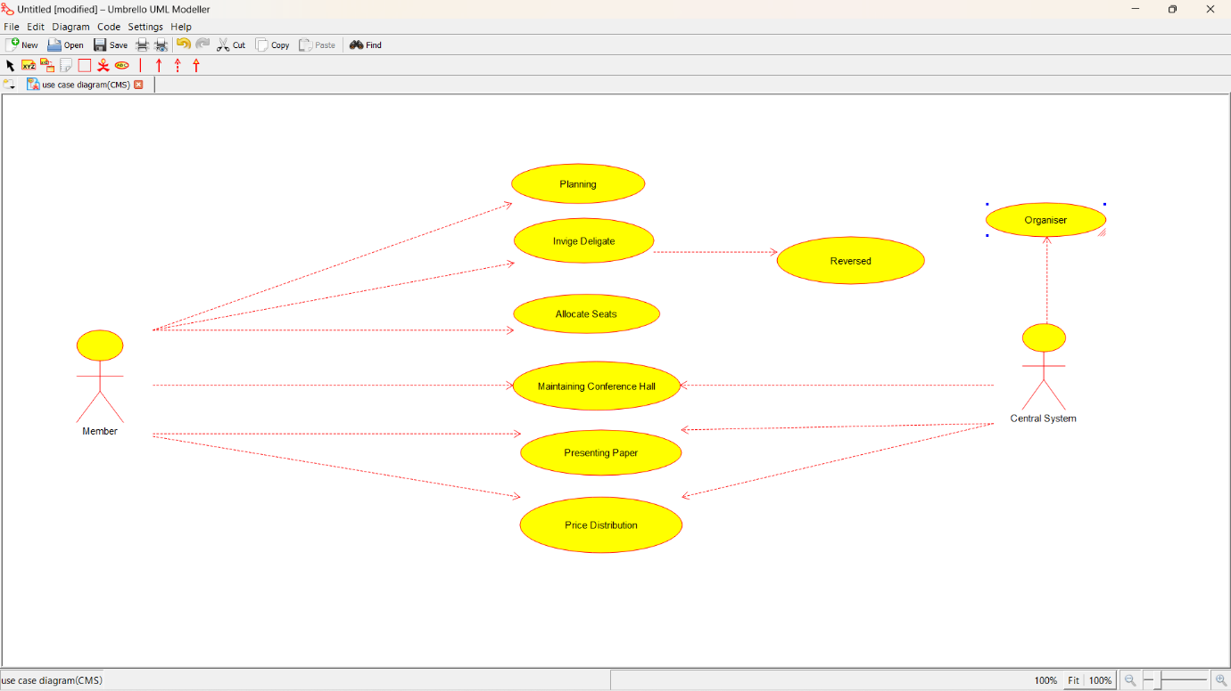

CLASS DIAGRAM:

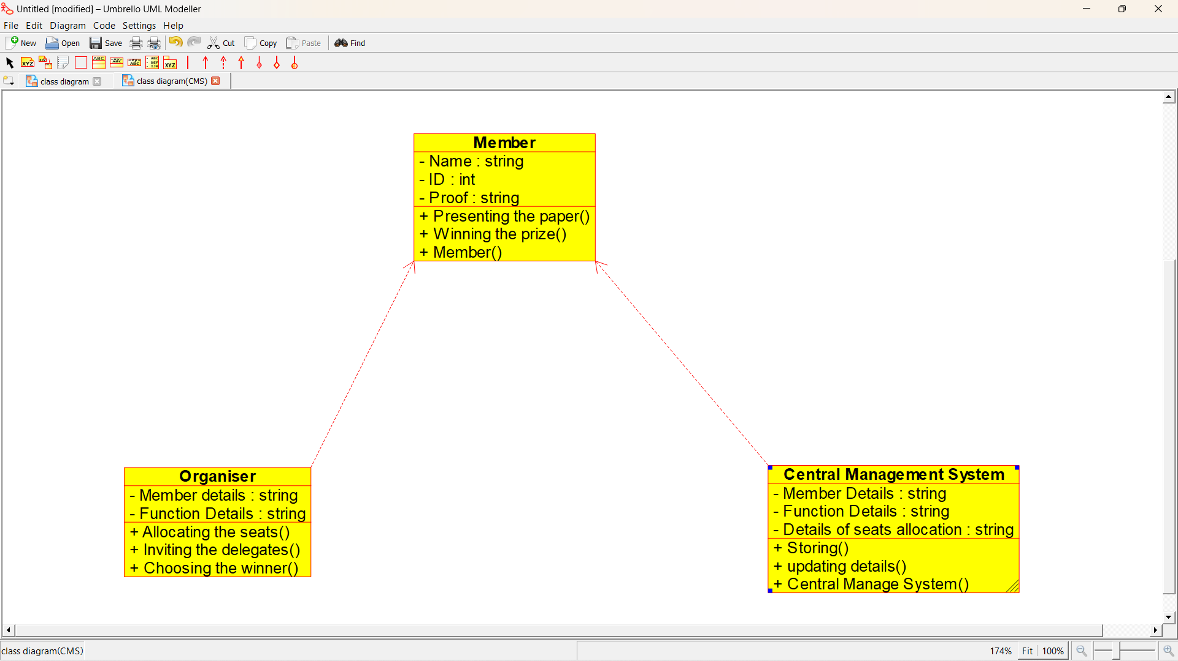

ACTIVITY DIAGRAM:

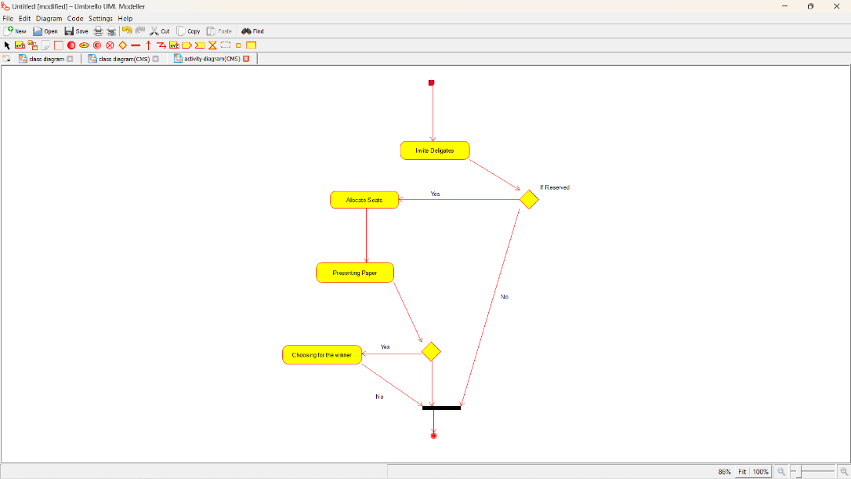

SEQUENCE DIAGRAM:

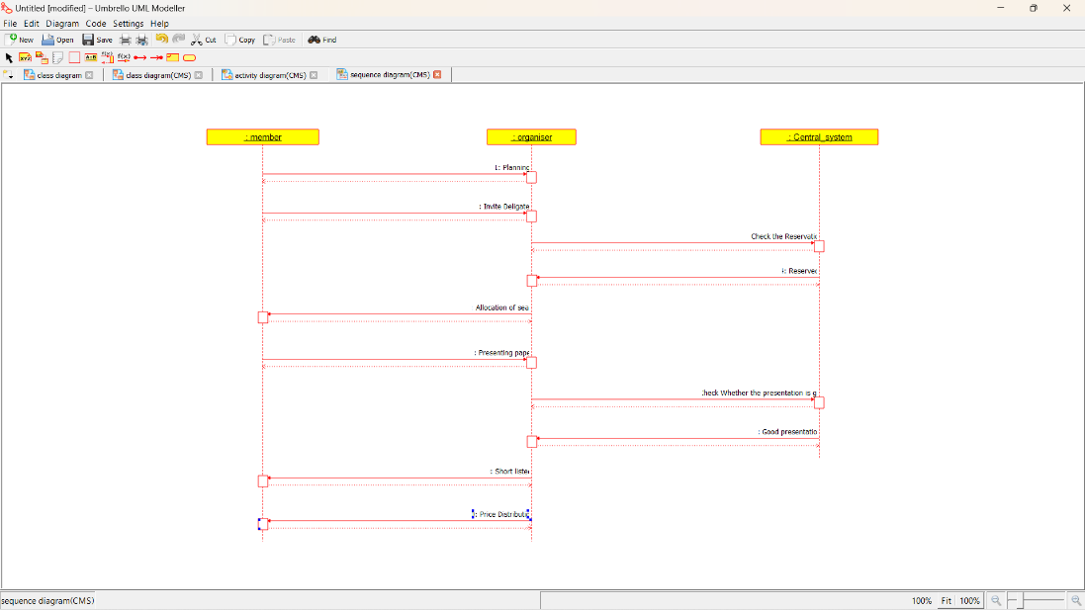

COLLABORATION DIAGRAM:

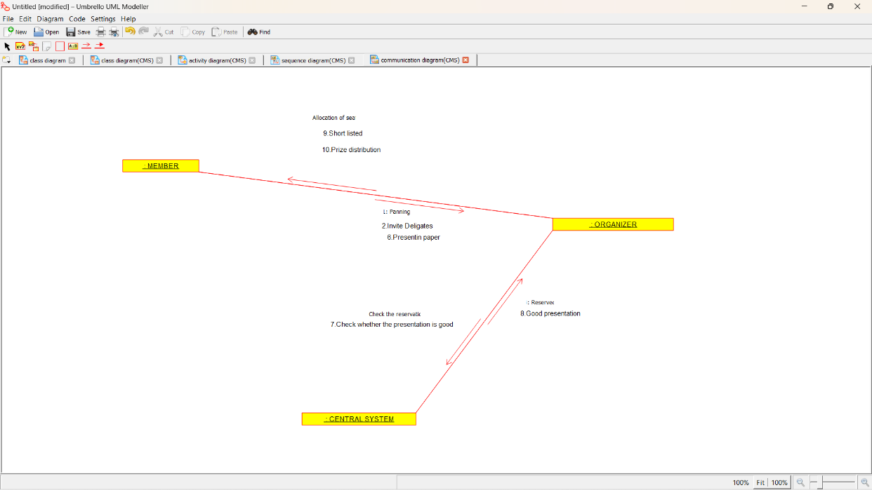

COMPONENT DIAGRAM:

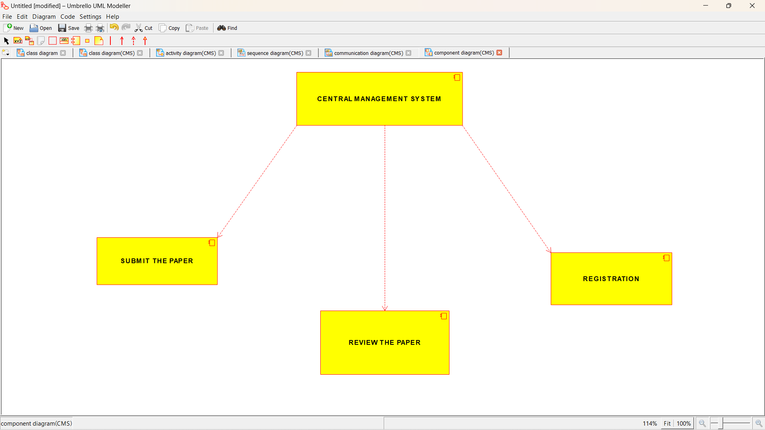

DEPLOYEMENT DIAGRAM:

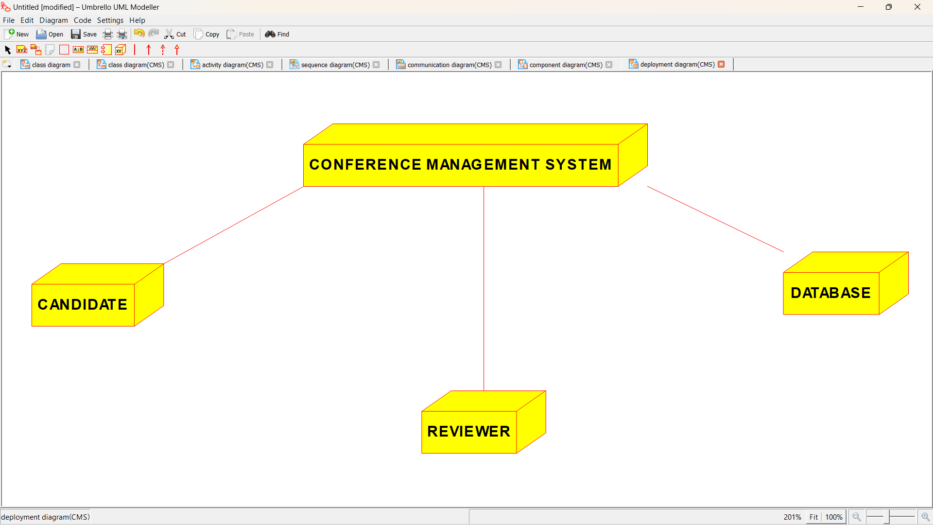

*PROGRAM CODING:*

/**

* Class Central_Management_System

*/

public class Central_Management_System

//

// Fields

//

private String Member_Details;

private String Function_Details;

private String Details_of_seats_allocation;

//

// Constructors

//

public Central_Management_System () { };

//

// Methods

//

//

// Accessor methods

//

/**

* Set the value of Member_Details

* @param newVar the new value of Member_Details

*/

private void setMember_Details (String newVar) {

Member_Details = newVar;

}

/**

* Get the value of Member_Details

* @return the value of Member_Details

*/

private String getMember_Details () {

return Member_Details;

}

/**

* Set the value of Function_Details

* @param newVar the new value of Function_Details

*/

private void setFunction_Details (String newVar) {

Function_Details = newVar;

}

/**

* Get the value of Function_Details

* @return the value of Function_Details

*/

private String getFunction_Details () {

return Function_Details;

}

/**

* Set the value of Details_of_seats_allocation

* @param newVar the new value of Details_of_seats_allocation

*/

private void setDetails_of_seats_allocation (String newVar) {

Details_of_seats_allocation = newVar;

}

/**

* Get the value of Details_of_seats_allocation

* @return the value of Details_of_seats_allocation

*/

private String getDetails_of_seats_allocation () {

return Details_of_seats_allocation;

}

//

// Other methods

//

/**

*/

public void Storing()

{

}

/**

*/

public void updating_details()

{

}

/**

*/

public void Central_Manage_System()

{

}

}

/**

* Class Member

*/

public class Member {

//

// Fields

//

private String Name;

private int ID;

private String Proof;

//

// Constructors

//

public Member () { };

//

// Methods

//

//

// Accessor methods

//

/**

* Set the value of Name

* @param newVar the new value of Name

*/

private void setName (String newVar) {

Name = newVar;

}

/**

* Get the value of Name

* @return the value of Name

*/

private String getName () {

return Name;

}

/**

* Set the value of ID

* @param newVar the new value of ID

*/

private void setID (int newVar) {

ID = newVar;

}

/**

* Get the value of ID

* @return the value of ID

*/

private int getID () {

return ID;

}

/**

* Set the value of Proof

* @param newVar the new value of Proof

*/

private void setProof (String newVar) {

Proof = newVar;

}

/**

* Get the value of Proof

* @return the value of Proof

*/

private String getProof () {

return Proof;

}

//

// Other methods

//

/**

*/

public void Presenting_the_paper()

{

}

/**

*/

public void Winning_the_prize()

{

}

/**

*/

public void Member()

{

}

}

/**

* Class Organiser

*/

public class Organiser {

//

// Fields

//

private String Member_details;

private String Function_Details;

//

// Constructors

//

public Organiser () { };

//

// Methods

//

//

// Accessor methods

//

/**

* Set the value of Member_details

* @param newVar the new value of Member_details

*/

private void setMember_details (String newVar) {

Member_details = newVar;

}

/**

* Get the value of Member_details

* @return the value of Member_details

*/

private String getMember_details () {

return Member_details;

}

/**

* Set the value of Function_Details

* @param newVar the new value of Function_Details

*/

private void setFunction_Details (String newVar) {

Function_Details = newVar;

}

/**

* Get the value of Function_Details

* @return the value of Function_Details

*/

private String getFunction_Details () {

return Function_Details;

}

//

// Other methods

//

/**

*/

public void Allocating_the_seats()

{

}

/**

*/

public void Inviting_the_delegates()

{

}

/**

*/

public void Choosing_the_winner()

{

}

}

EXPERIMENT – 12 FOREIGN TRADING SYSTEM

USECASE DIGRAM :-CC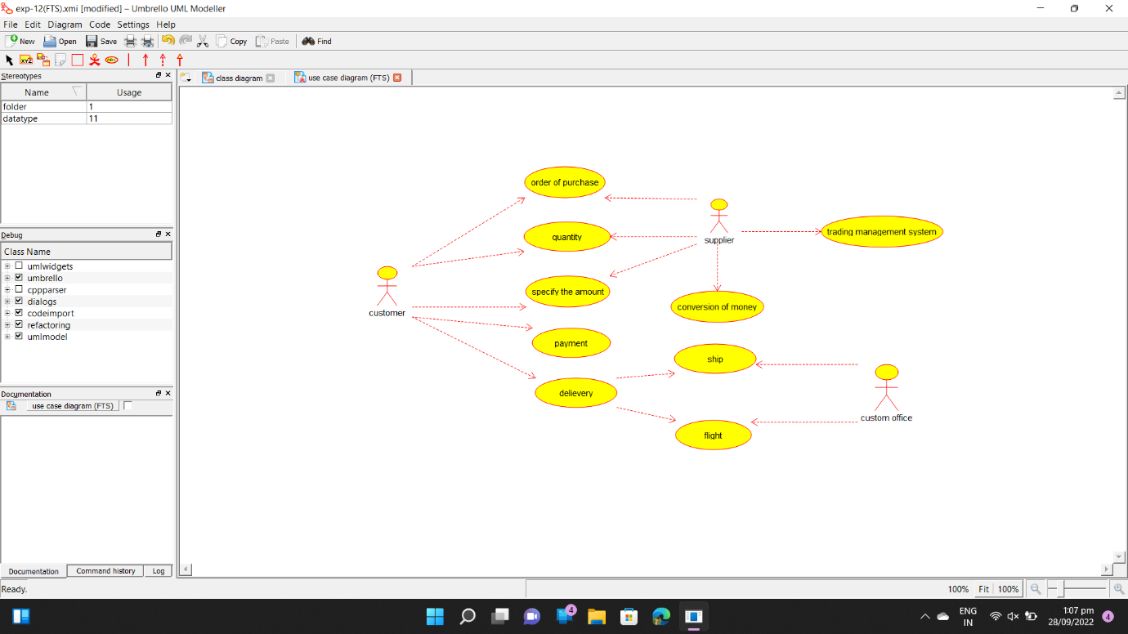

CLASS DIAGRAM :-

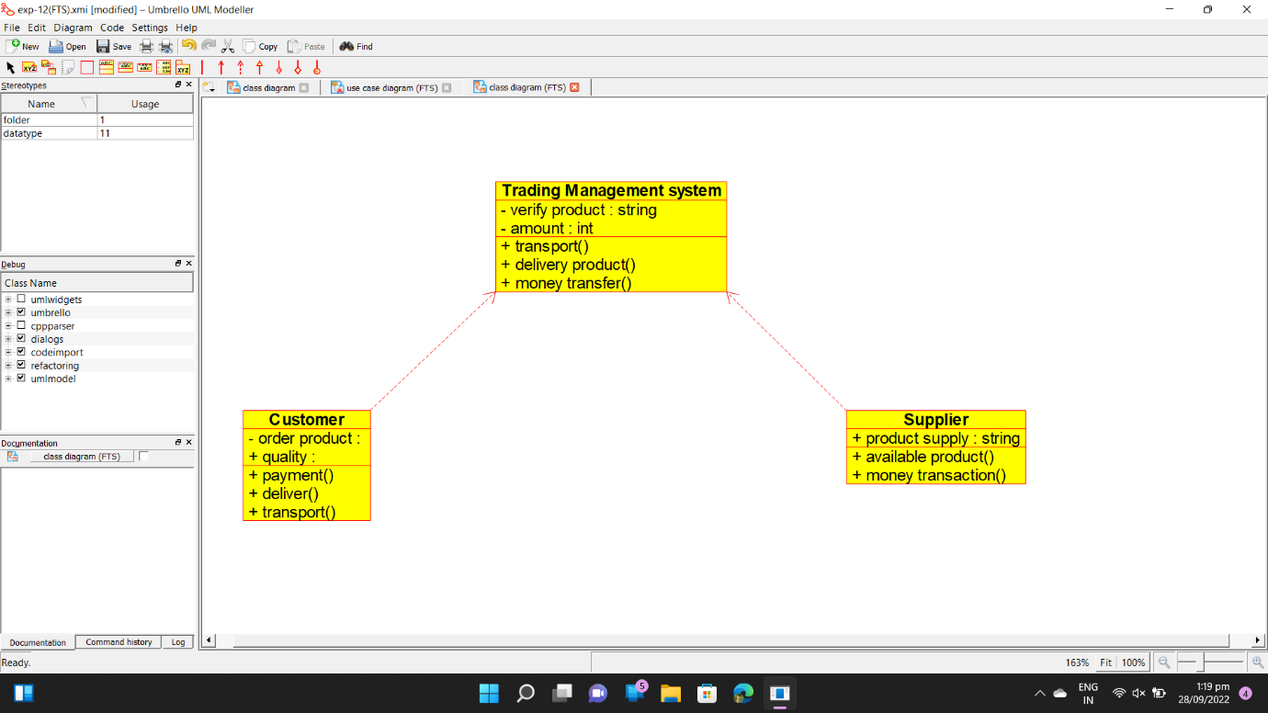

ACTIVITY DIAGRAM :- 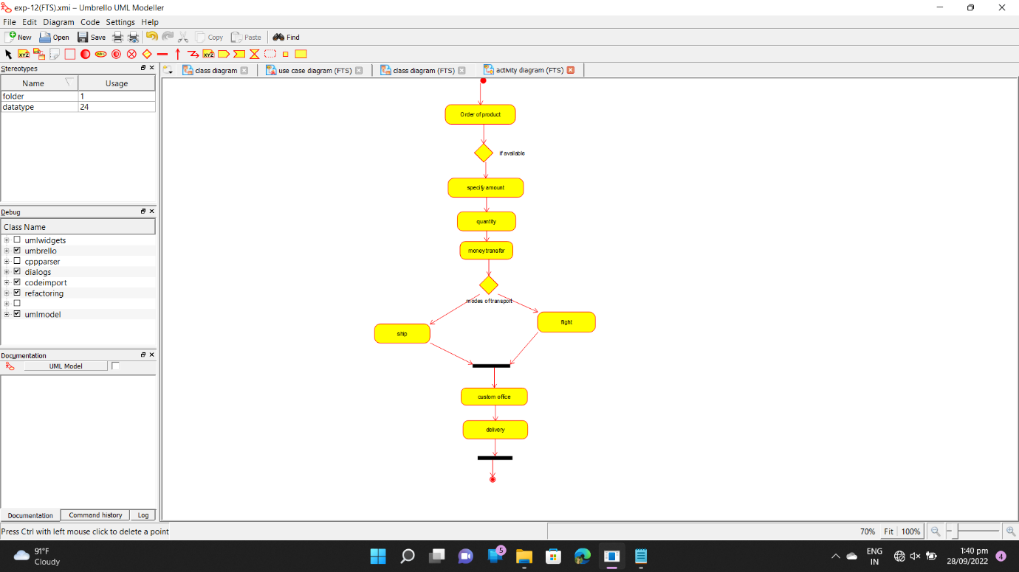

SEQUENCE DIAGRAM :- 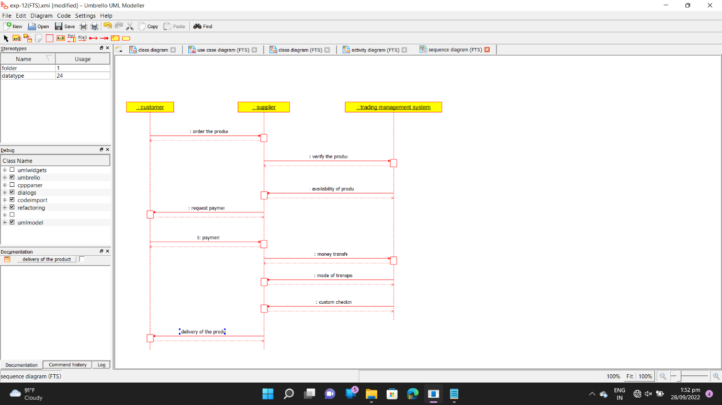

COLLABORATION DIAGRAM :- 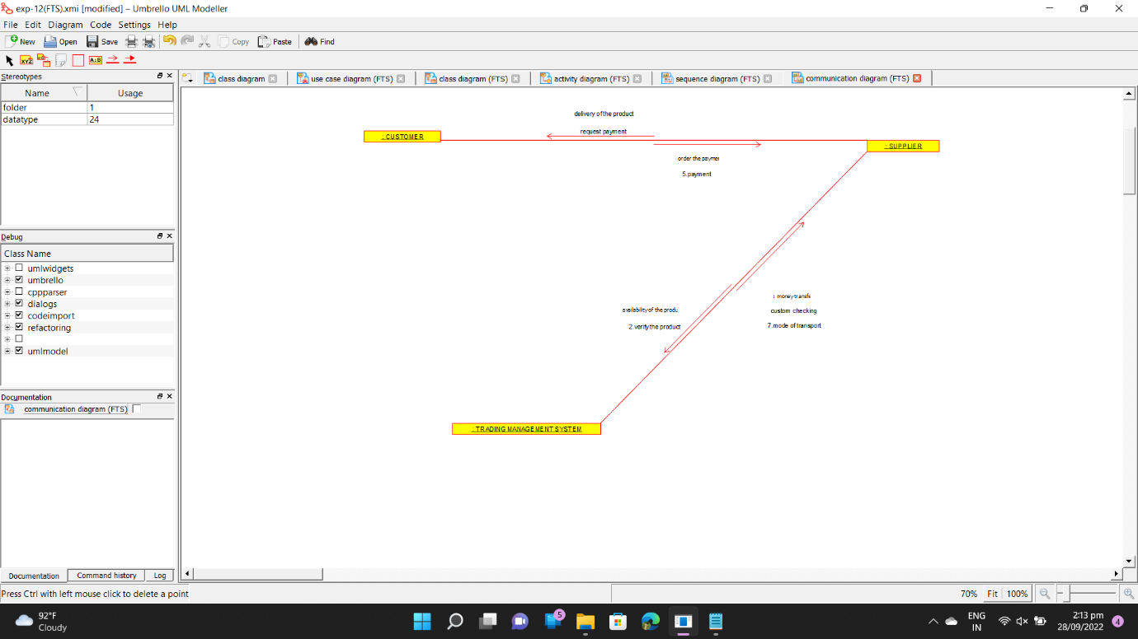

STATECHART DIAGRAM :-

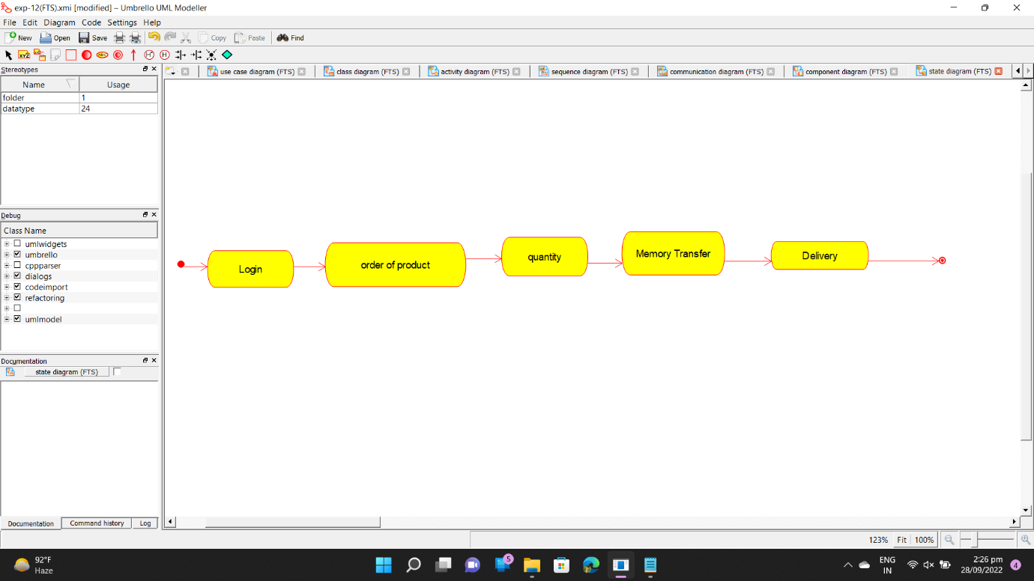

COMPONENT DIGRAM :- 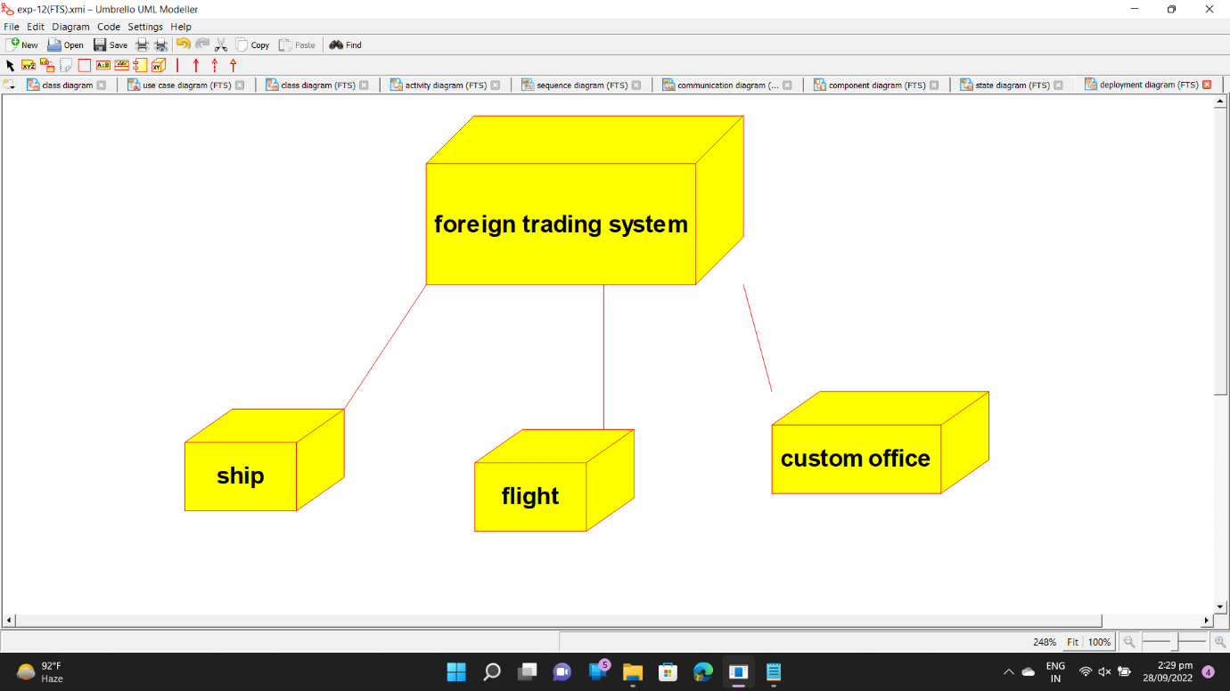

DEPLOYMENT DIAGRAM :-

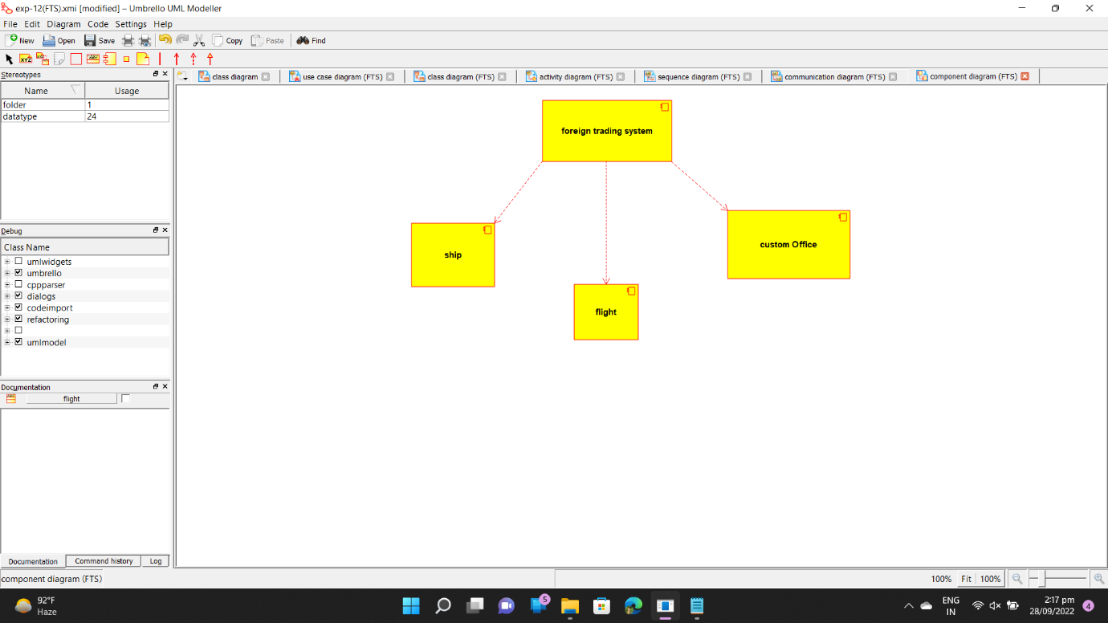

PROGRAM CODE :-

/**

* Class Customer

*/

public class Customer {

//

// Fields

//

public void quality;

private void order_product;

//

// Constructors

//

public Customer () { };

//

// Methods

//

//

// Accessor methods

//

/**

* Set the value of quality

* @param newVar the new value of quality

*/

public void setQuality (void newVar) {

quality = newVar;

}

/**

* Get the value of quality

* @return the value of quality

*/

public void getQuality () {

return quality;

}

/**

* Set the value of order_product

* @param newVar the new value of order_product

*/

private void setOrder_product (void newVar) {

order_product = newVar;

}

/**

* Get the value of order_product

* @return the value of order_product

*/

private void getOrder_product () {

return order_product;

}

//

// Other methods

//

/**

*/

public void payment()

{

}

/**

*/

public void deliver()

{

}

/**

*/

public void transport()

{

}

/**

* Class Supplier

*/

public class Supplier {

//

// Fields

//

public String product_supply;

//

// Constructors

//

public Supplier () { };

//

// Methods

//

//

// Accessor methods

//

/**

* Set the value of product_supply

* @param newVar the new value of product_supply

*/

public void setProduct_supply (String newVar) {

product_supply = newVar;

}

/**

* Get the value of product_supply

* @return the value of product_supply

*/

public String getProduct_supply () {

return product_supply;

}

//

// Other methods

//

/**

*/

public void available_product()

{

}

/**

*/

public void money_transaction()

{

}

}

/**

* Class Trading_Management_system

*/

public class Trading_Management_system {

//

// Fields

//

private String verify_product;

private int amount;

//

// Constructors

//

public Trading_Management_system () { };

//

// Methods

//

//

// Accessor methods

//

/**

* Set the value of verify_product

* @param newVar the new value of verify_product

*/

private void setVerify_product (String newVar) {

verify_product = newVar;

}

/**

* Get the value of verify_product

* @return the value of verify_product

*/

private String getVerify_product () {

return verify_product;

}

/**

* Set the value of amount

* @param newVar the new value of amount

*/

private void setAmount (int newVar) {

amount = newVar;

}

/**

* Get the value of amount

* @return the value of amount

*/

private int getAmount () {

return amount;

}

//

// Other methods

//

/**

*/

public void transport()

{

}

/**

*/

public void delivery_product()

{

}

/**

*/

public void money_transfer()

{

}

}

**BPO MANAGEMENT SYSTEM**

**USECASE DIAGRAM:**

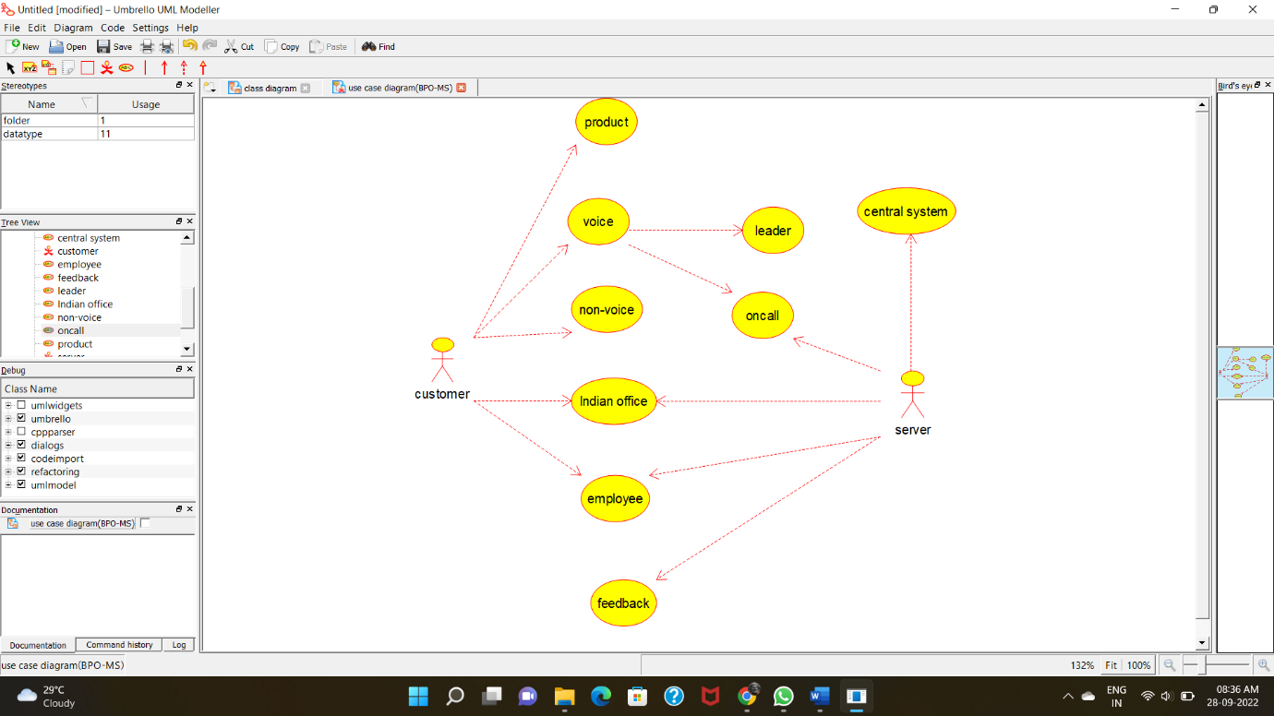

**CLASS DIAGRAM:**

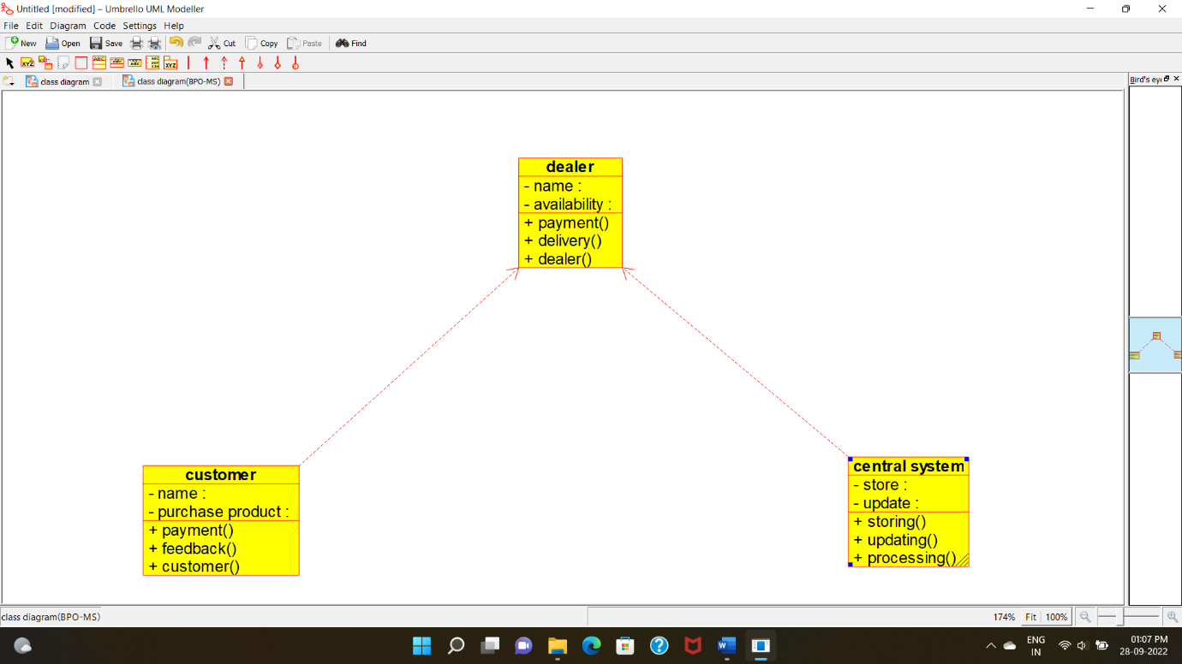

**ACTIVITY DIAGRAM:**

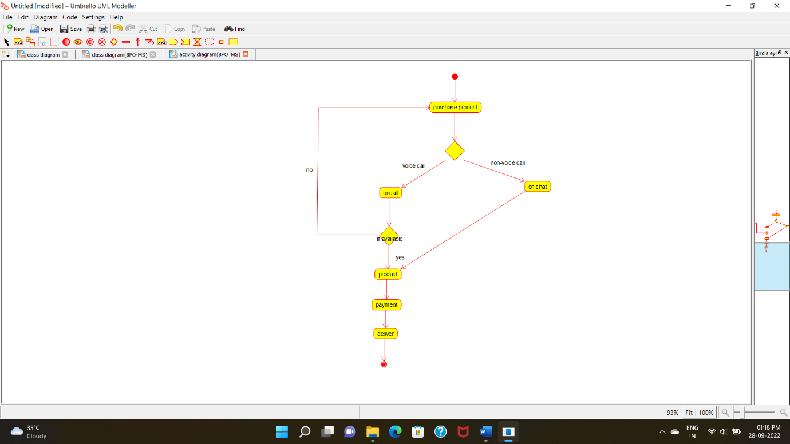

**SEQUENCE DIAGRAM**:

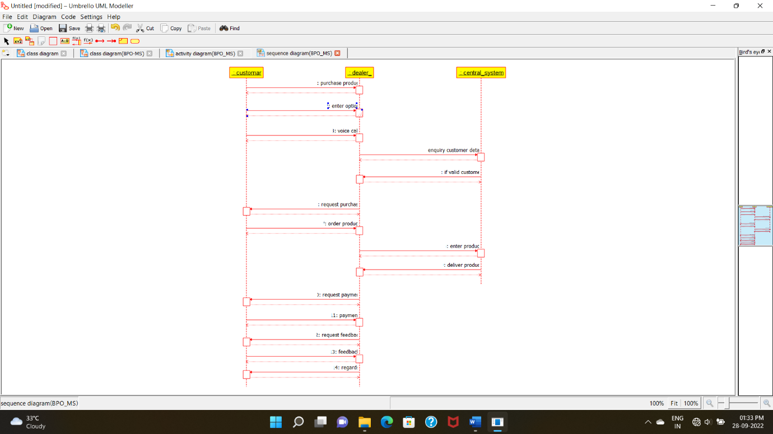

**COLLABORATION DIAGRAM:**

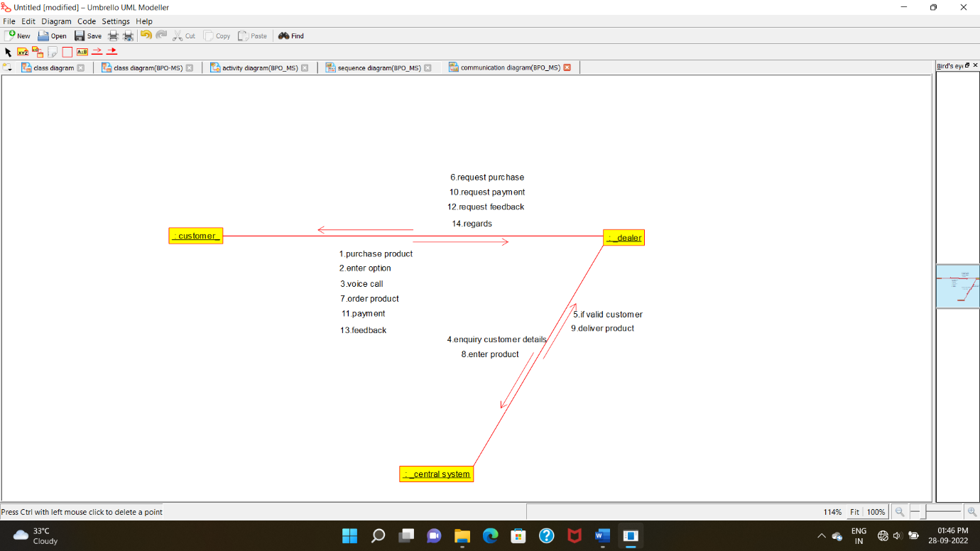

**STATECHART DIAGRAM**:

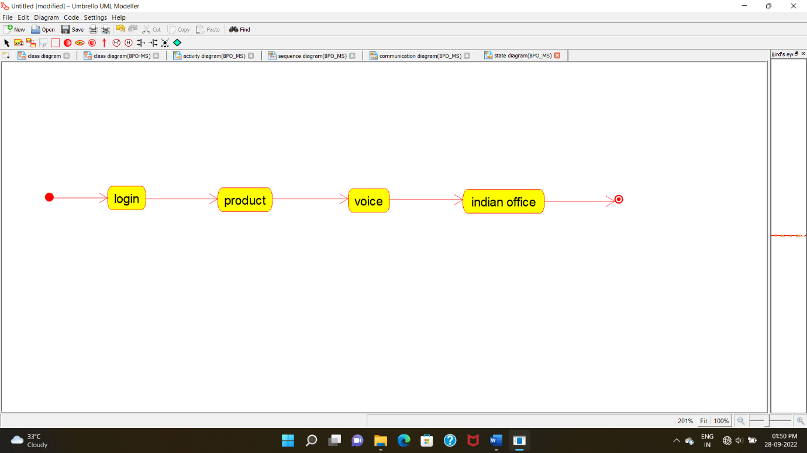

**COMPONENT DIAGRAM:**

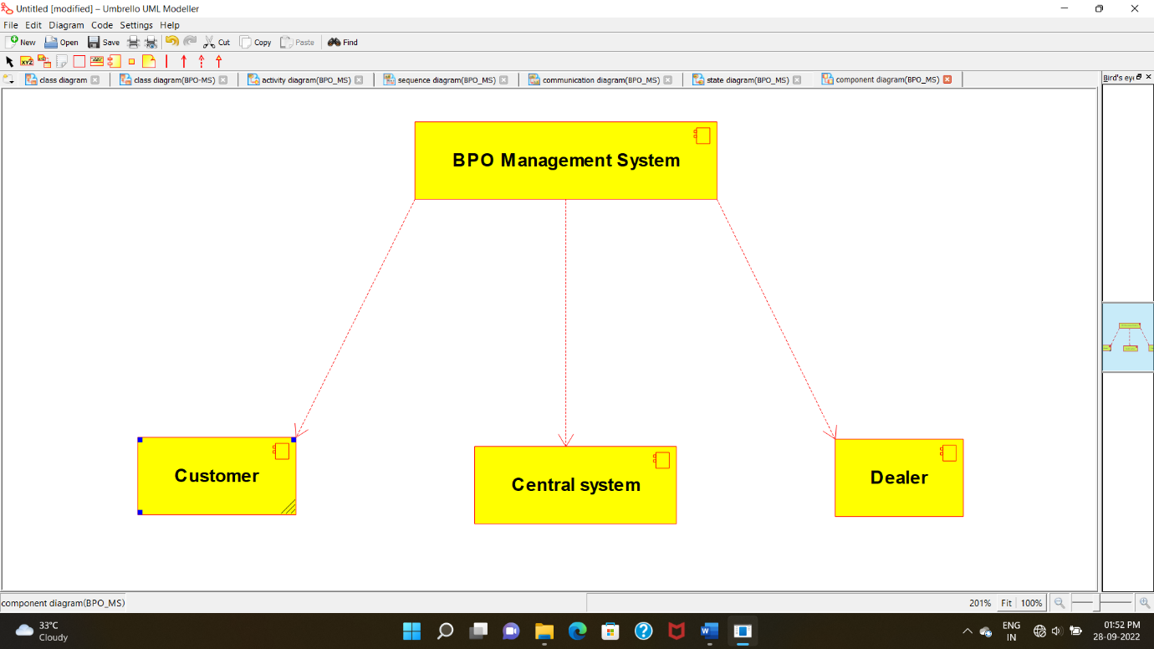

**DEPLOYMENT DIAGRAM**:

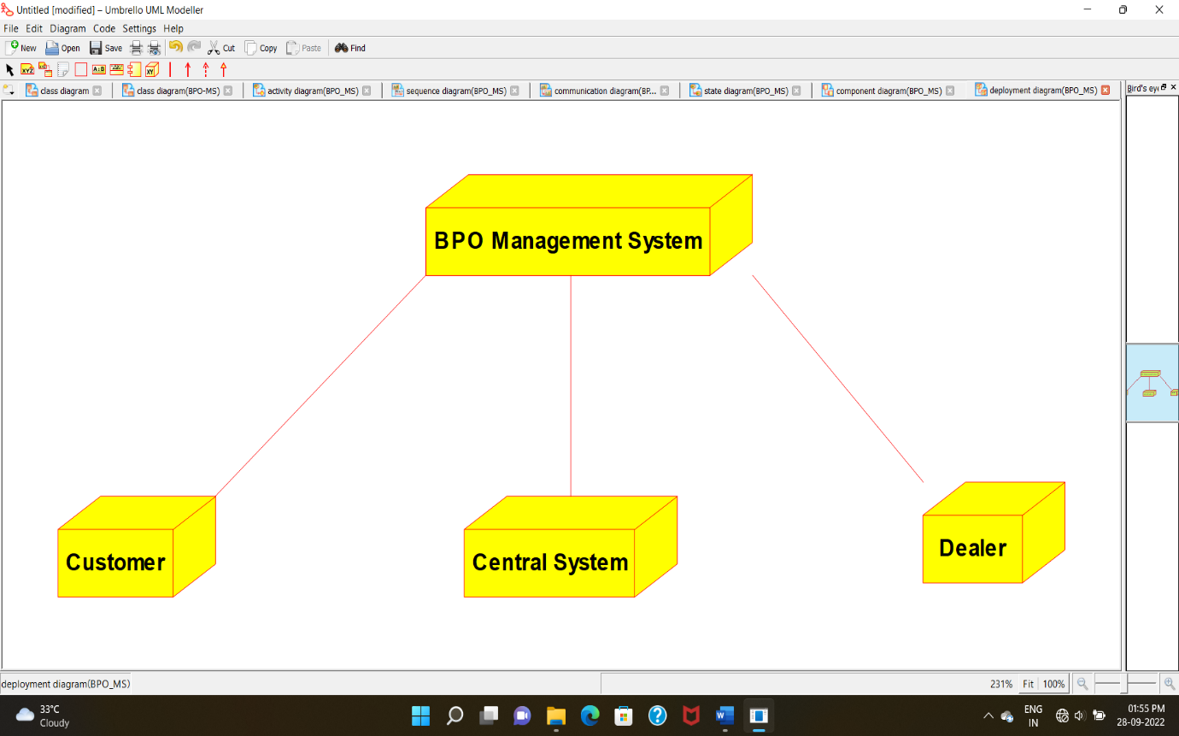

**PROGRAM CODING:**

**CENTRAL SYSTEM*:***

/**

* Class central_system

*/

public class central_system {

//

// Fields

//

private void store;

private void update;

//

// Constructors

//

public central_system () { };

//

// Methods

//

//

// Accessor methods

//

/**

* Set the value of store

* @param newVar the new value of store

*/

private void setStore (void newVar) {

store = newVar;

}

/**

* Get the value of store

* @return the value of store

*/

private void getStore () {

return store;

}

/**

* Set the value of update

* @param newVar the new value of update

*/

private void setUpdate (void newVar) {

update = newVar;

}

/**

* Get the value of update

* @return the value of update

*/

private void getUpdate () {

return update;

}

//

// Other methods

//

/**

*/

public void storing()

{

}

/**

*/

public void updating()

{

}

/**

*/

public void processing()

{

}

}

**CUSTOMER:**

/**

* Class customer

*/

public class customer {

//

// Fields

//

private void name;

private void purchase_product;

//

// Constructors

//

public customer () { };

//

// Methods

//

//

// Accessor methods

//

/**

* Set the value of name

* @param newVar the new value of name

*/

private void setName (void newVar) {

name = newVar;

}

/**

* Get the value of name

* @return the value of name

*/

private void getName () {

return name;

}

/**

* Set the value of purchase_product

* @param newVar the new value of purchase_product

*/

private void setPurchase_product (void newVar) {

purchase_product = newVar;

}

/**

* Get the value of purchase_product

* @return the value of purchase_product

*/

private void getPurchase_product () {

return purchase_product;

}

//

// Other methods

//

/**

*/

public void payment()

{

}

/**

*/

public void feedback()

{

}

/**

*/

public void customer()

{

}

}

**DEALER:**

/**

* Class dealer

*/

public class dealer {

//

// Fields

//

private void name;

private void availability;

//

// Constructors

//

public dealer () { };

//

// Methods

//

//

// Accessor methods

//

/**

* Set the value of name

* @param newVar the new value of name

*/

private void setName (void newVar) {

name = newVar;

}

/**

* Get the value of name

* @return the value of name

*/

private void getName () {

return name;

}

/**

* Set the value of availability

* @param newVar the new value of availability

*/

private void setAvailability (void newVar) {

availability = newVar;

}

/**

* Get the value of availability

* @return the value of availability

*/

private void getAvailability () {

return availability;

}

//

// Other methods

//

/**

*/

public void payment()

{

}

/**

*/

public void delivery()

{

}

/**

*/

public void dealer()

{

}

}

**:-(E - COMMERCE SYSTEM)**

**1) USE CASE DIAGRAM**

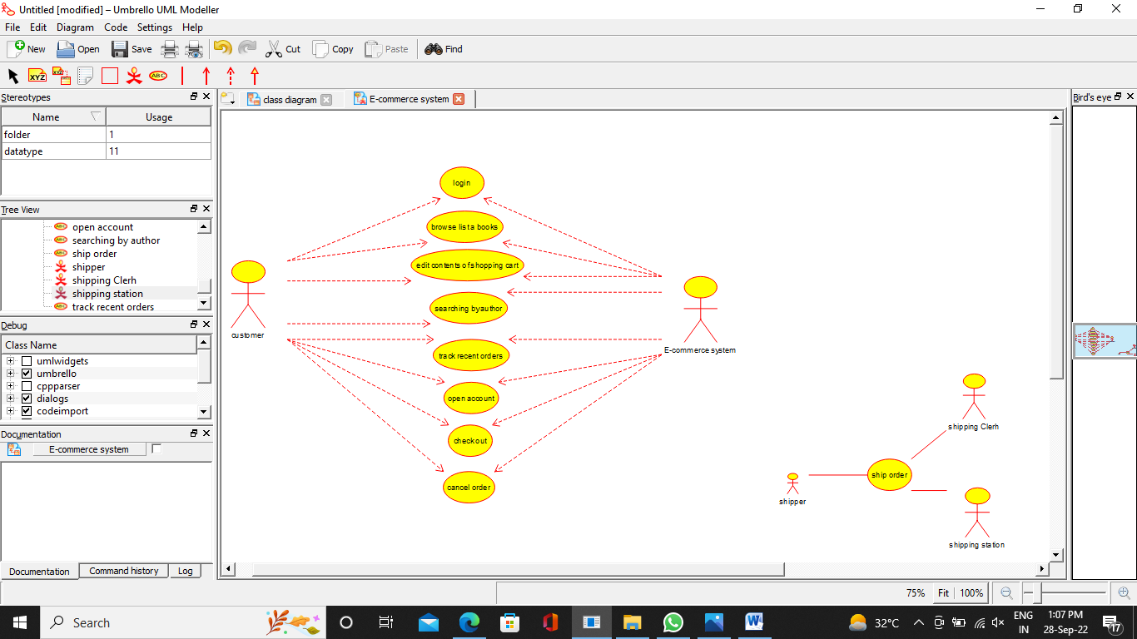

**2) CLASS DIAGRAM**

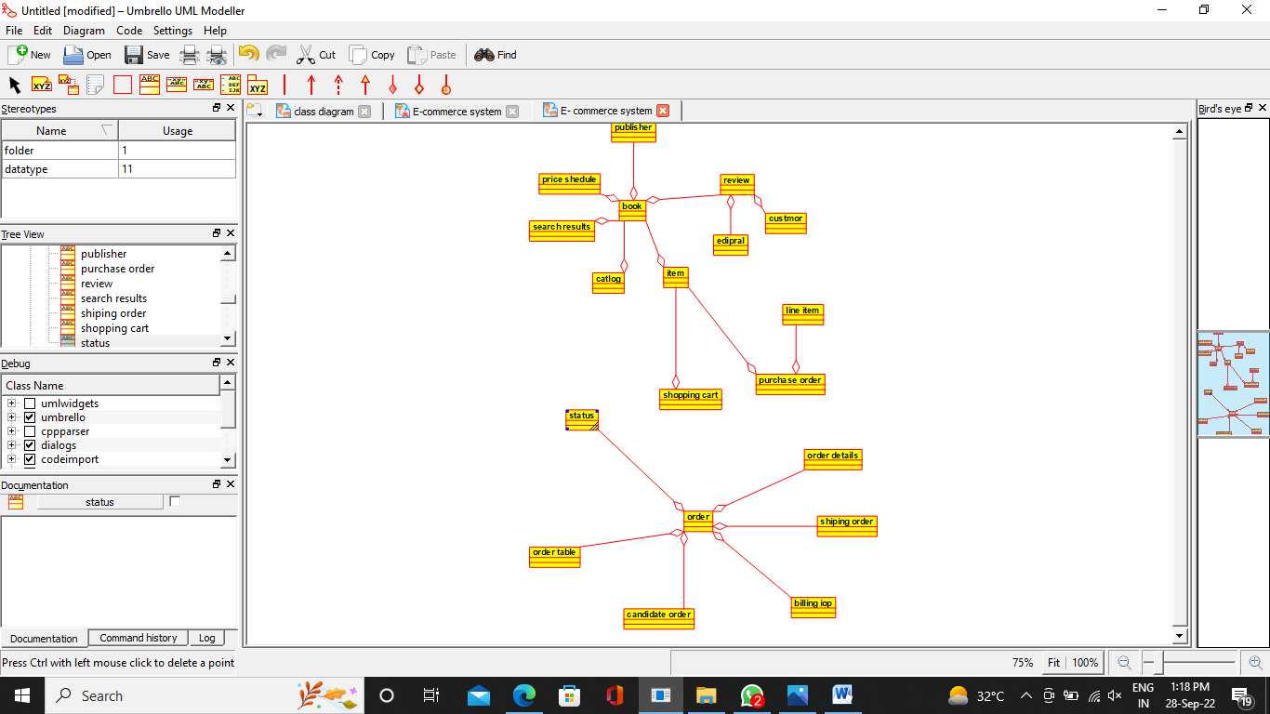

**3) ACTIVITY DIAGRAM**

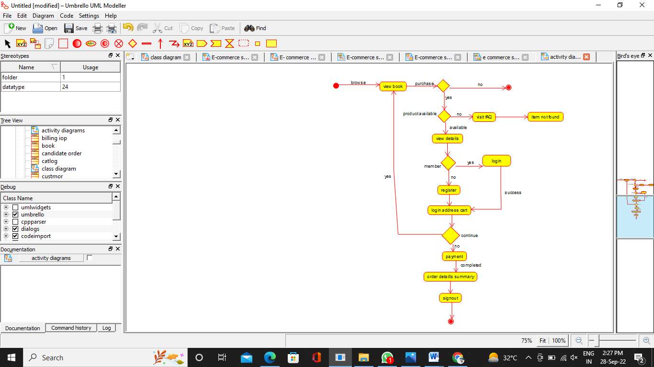

**4) SEQUENCE DIAGRAM**

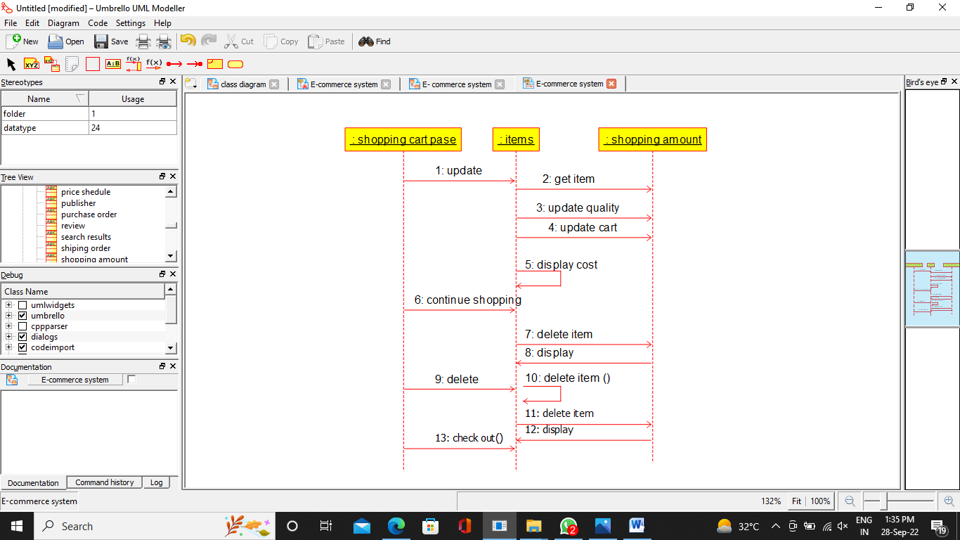

**5) COLLABORATION DIAGRAM**

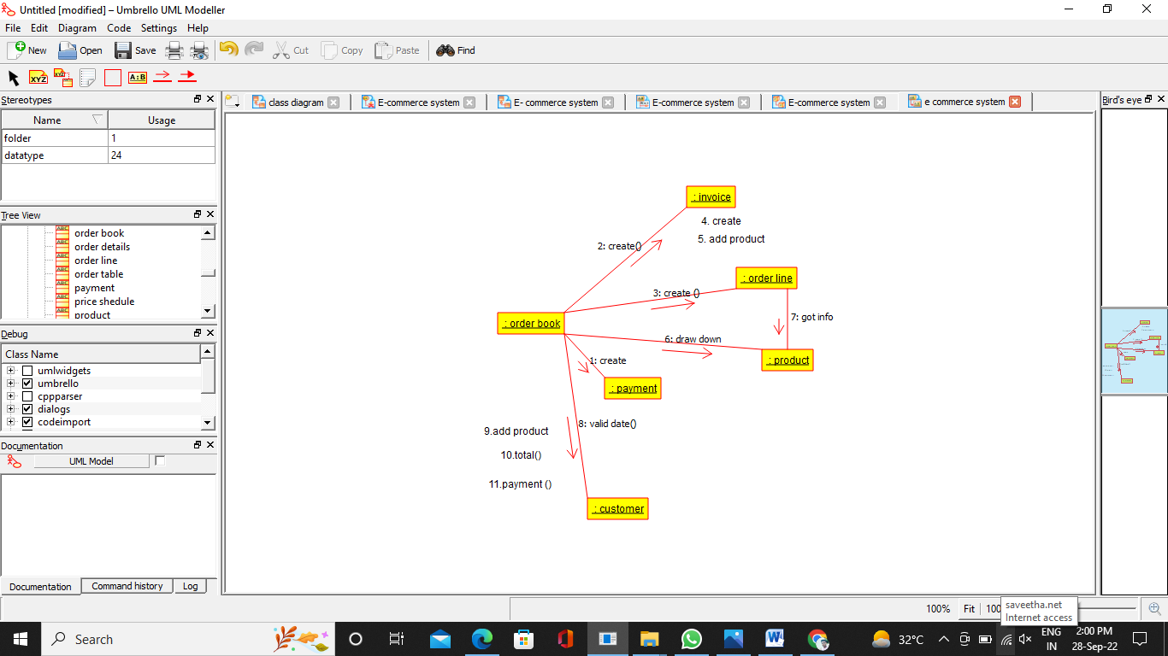

**6) COMPONENT DIAGRAM**

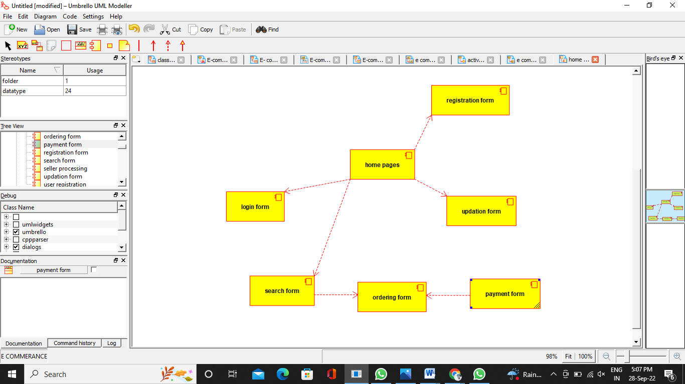

**7) DEPLOYMENT DIAGRAM**

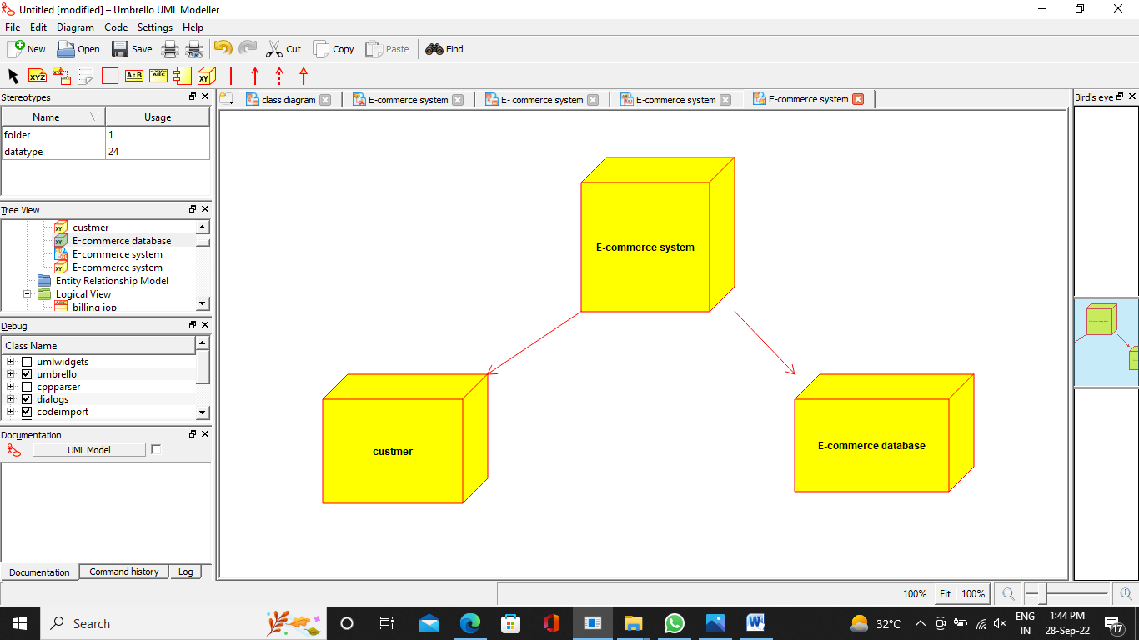

***PROGRAM CODING:***

**import java.util.*;**

**/\*\***

**\* Class book**

**\*/**

**public class book {**

**//**

**// Fields**

**//**

**//**

**// Constructors**

**//**

**public book () { };**

**//**

**// Methods**

**//**

**//**

**// Accessor methods**

**//**

**//**

**// Other methods**

**//**

**}**

**import java.util.*;**

**/\*\***

**\* Class publisher**

**\*/**

**public class publisher {**

**//**

**// Fields**

**//**

**//**

**// Constructors**

**//**

**public publisher () { };**

**//**

**// Methods**

**// Accessor methods**

**//**

**//**

**// Other methods**

**//**

**}**

**import java.util.*;**

**/\*\***

**\* Class shiping_order**

**\*/**

**public class shiping_order {**

**//**

**// Fields**

**//**

**//**

**// Constructors**

**//**

**public shiping_order () { };**

**//**

**// Methods**

**//**

**//**

**// Accessor methods**

**//**

**//**

**// Other methods**

**//**

**}**

**import java.util.*;**

**/\*\***

**\* Class shopping_cart**

**\*/**

**public class shopping_cart {**

**//**

**// Fields**

**//**

**//**

**// Constructors**

**//**

**public shopping_cart () { };**

**//**

**// Methods**

**//**

**// Accessor methods**

**//**

**//**

**// Other methods**

**//**

**}**

**USE CASE DIAGRAM**:

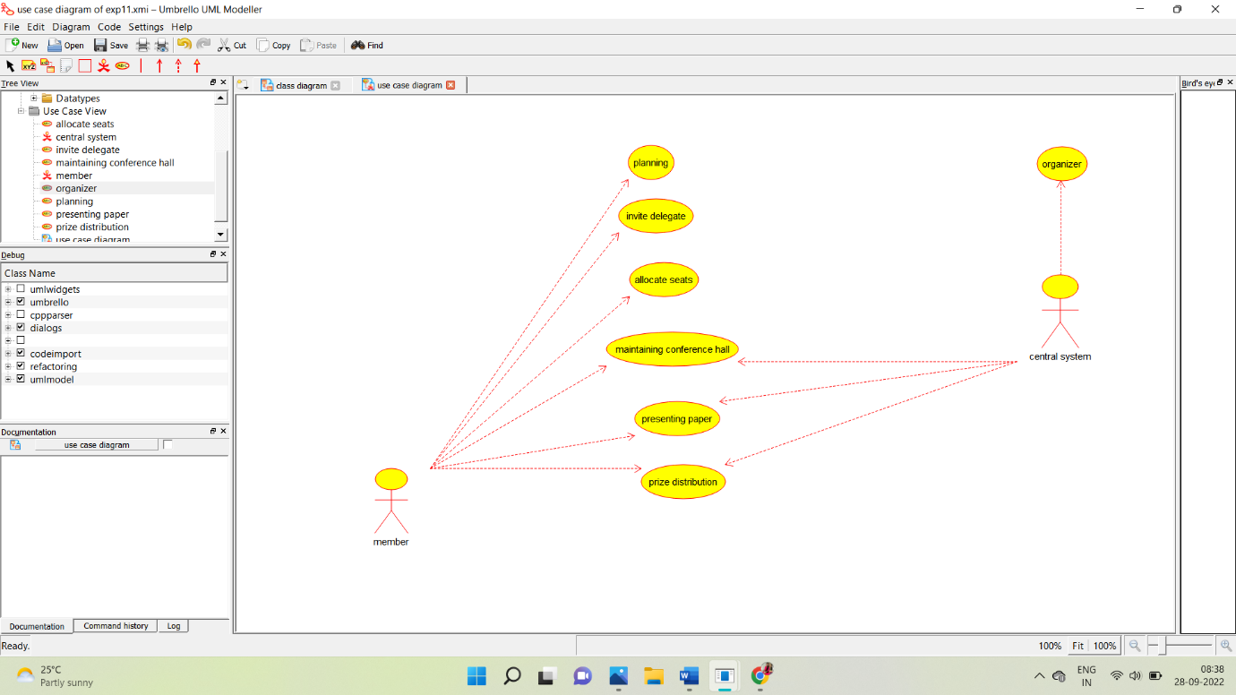

**CLASS DIAGRAM:**

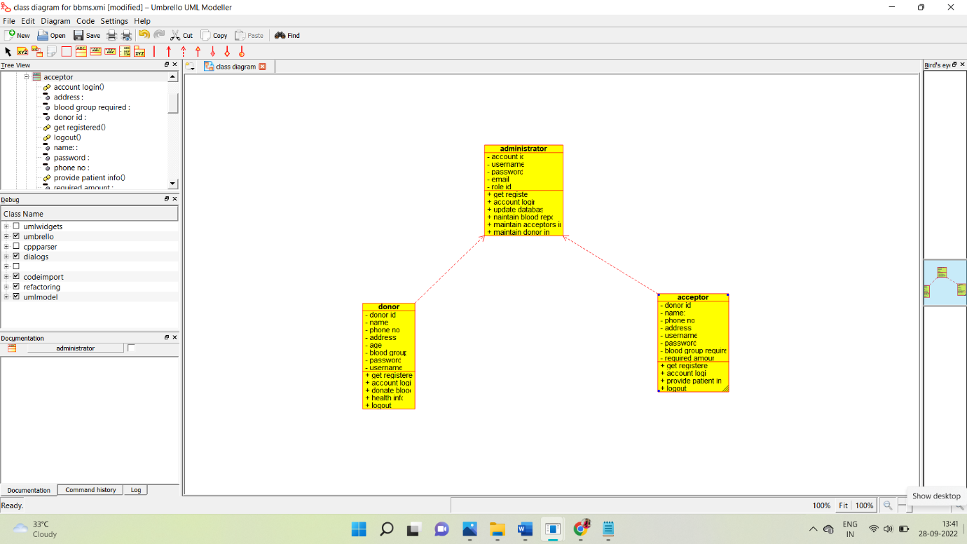

**ACTIVITY DIAGRAM:**

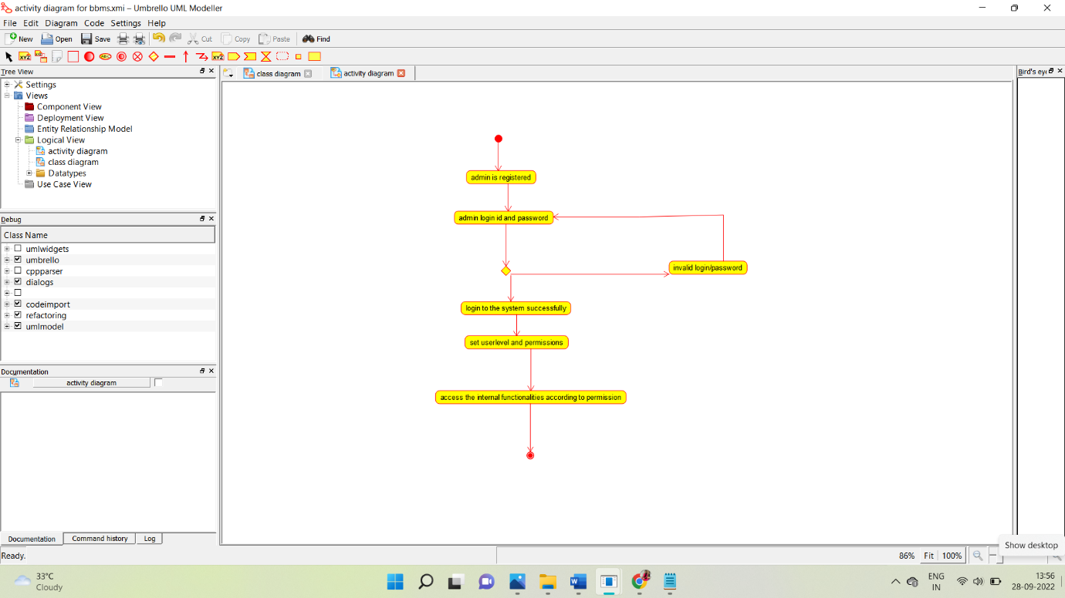

**SEQUENCE DIAGRAM:**

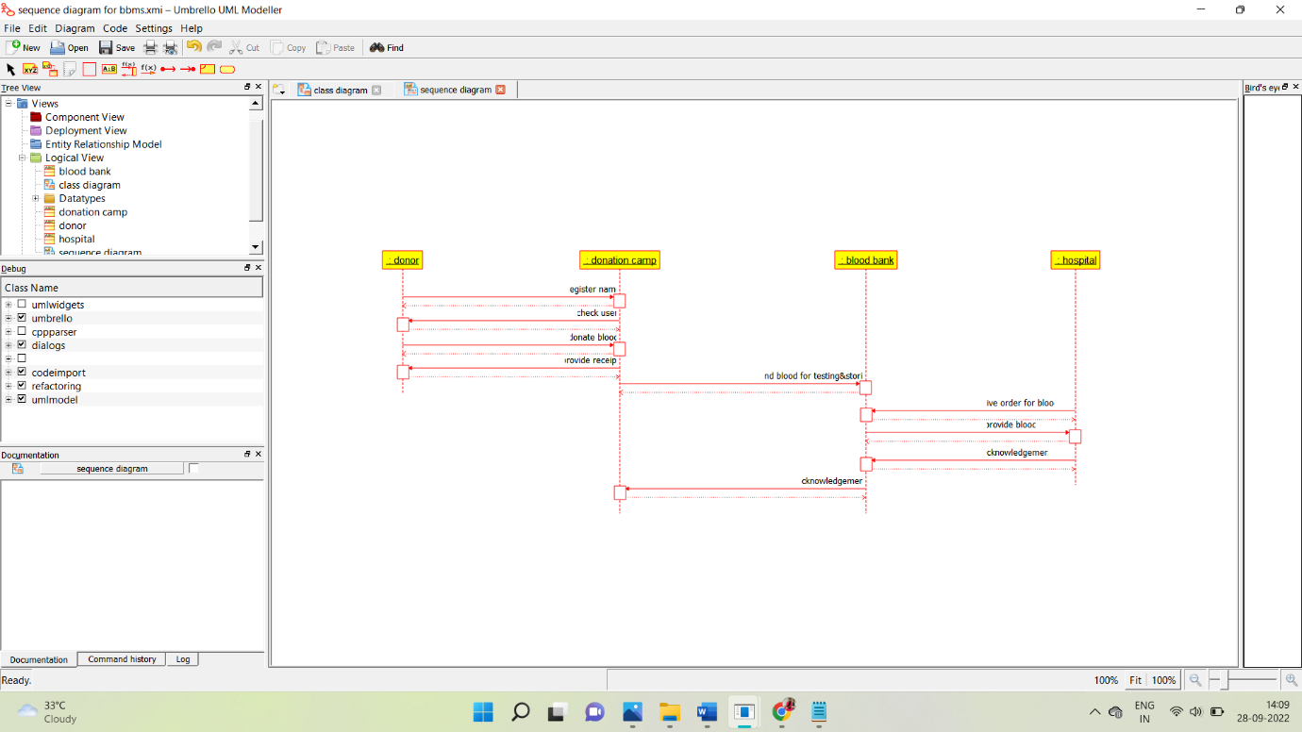

**COLLABORATION DIAGRAM:**

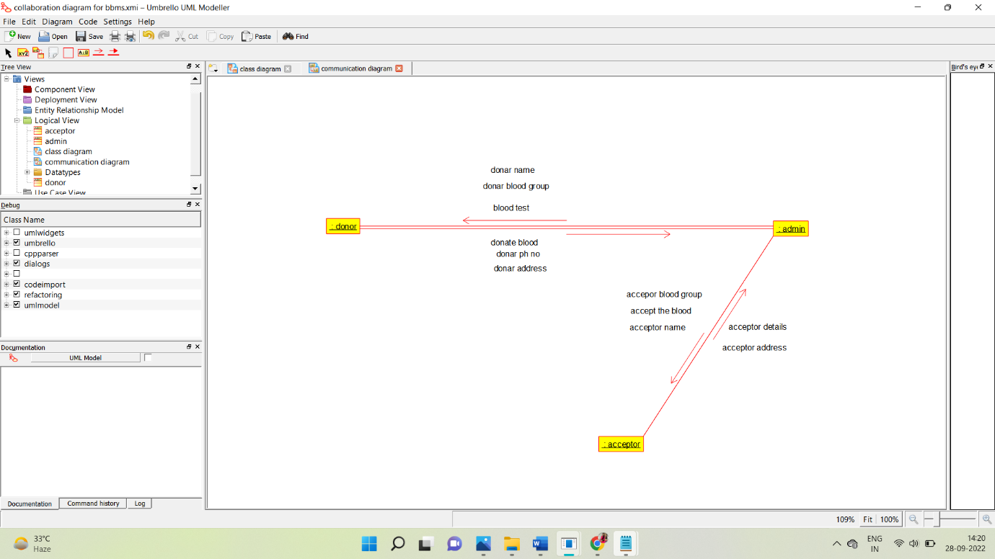

**STATE CHART DIAGRAM:**

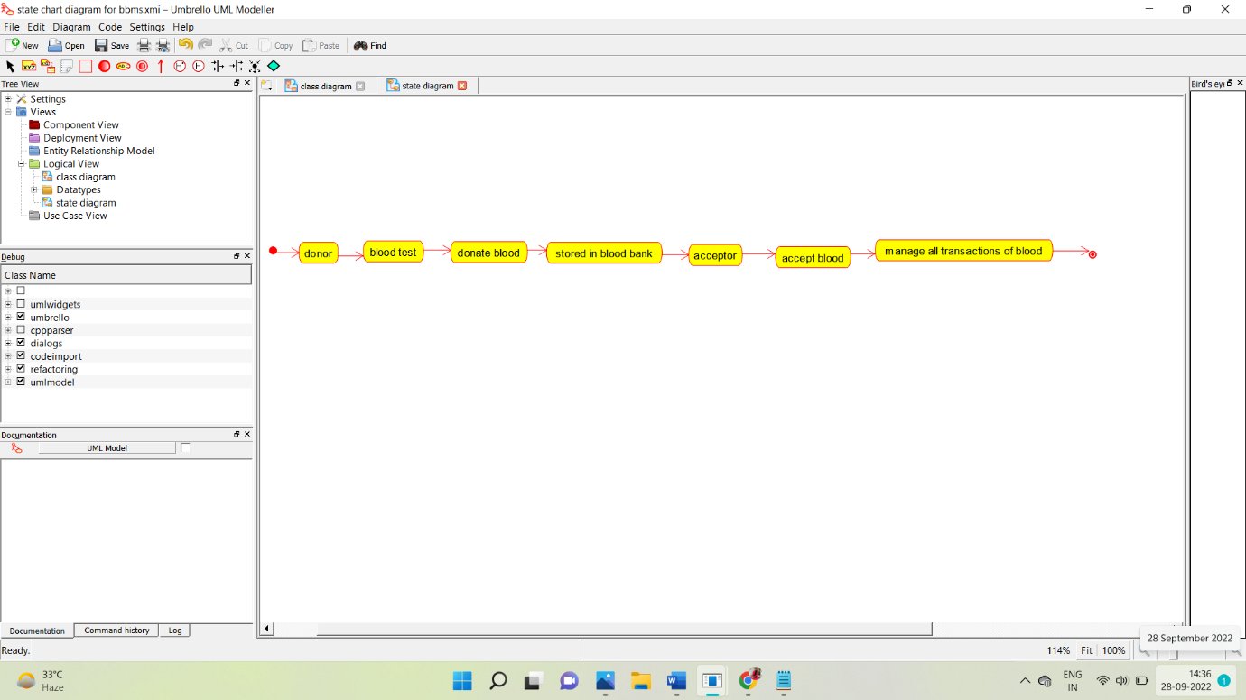

**COMPONENT DIAGRAM:**

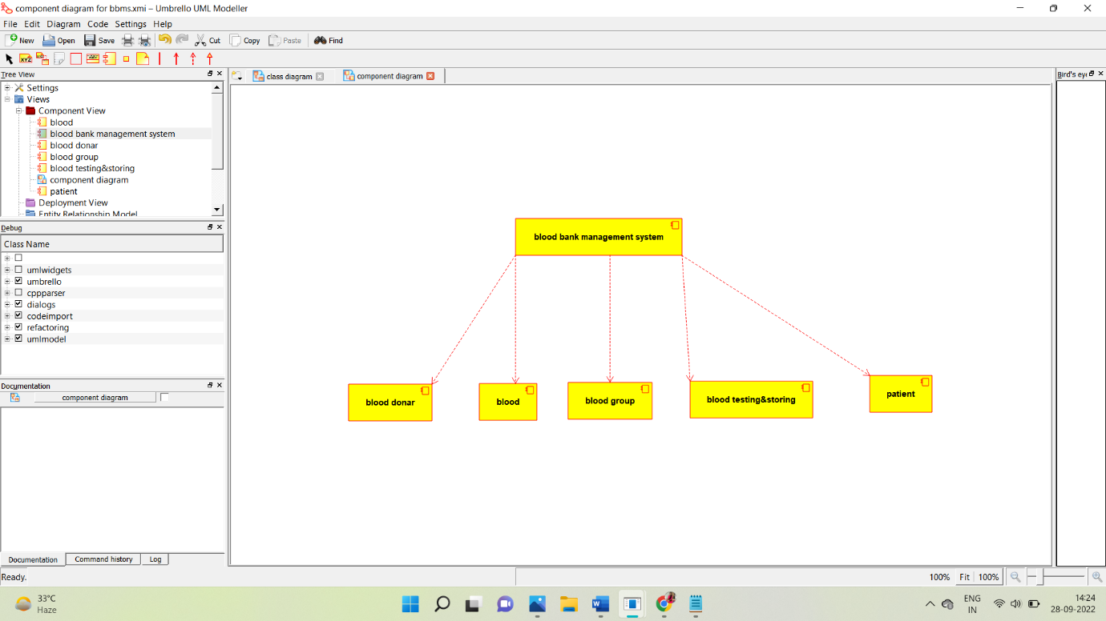

**DEPLOYMENT DIAGRAM:**

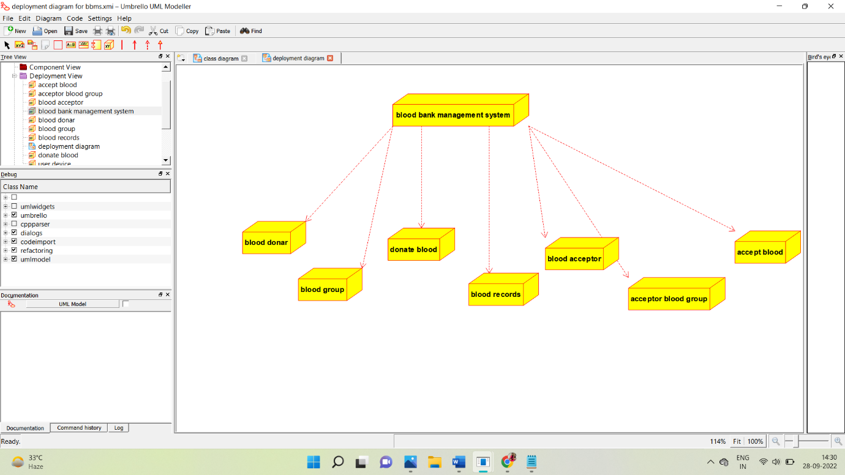

**PROGRAM:**

**[1:39 PM, 9/28/2022] 😊😊😊😊: /\*\***

**\* Class administrator**

**\*/**

**public class administrator {**

**//**

**// Fields**

**//**

**private void account_id;**

**private void username;**

**private void password;**

**private void email;**

**private void role_id;**

**//**

**// Constructors**

**//**

**public administrator () { };**

**//**

**// Methods**

**//**

**//**

**// Accessor methods**

**//**

**/\*\***

**\* Set the value of account_id**

**\* @param newVar the new value of account_id**

**\*/**

**private void setAccount_id (void newVar) {**

**account_id = newVar;**

**}**

**/\*\***

**\* Get the value of account_id**

**\* @return the value of account_id**

**\*/**

**private void getAccount_id () {**

**return account_id;**

**}**

**/\*\***

**\* Set the value of username**

**\* @param newVar the new value of username**

**\*/**

**private void setUsername (void newVar) {**

**username = newVar;**

**}**

**/\*\***

**\* Get the value of username**

**\* @return the value of username**

**\*/**

**private void getUsername () {**

**return username;**

**}**

**/\*\***

**\* Set the value of password**

**\* @param newVar the new value of password**

**\*/**

**private void setPassword (void newVar) {**

**password = newVar;**

**}**

**/\*\***

**\* Get the value of password**

**\* @return the value of password**

**\*/**

**private void getPassword () {**

**return password;**

**}**

**/\*\***

**\* Set the value of email**

**\* @param newVar the new value of email**

**\*/**

**private void setEmail (void newVar) {**

**email = newVar;**

**}**

**/\*\***

**\* Get the value of email**

**\* @return the value of email**

**\*/**

**private void getEmail () {**

**return email;**

**}**

**/\*\***

**\* Set the value of role_id**

**\* @param newVar the new value of role_id**

**\*/**

**private void setRole_id (void newVar) {**

**role_id = newVar;**

**}**

**/\*\***

**\* Get the value of role_id**

**\* @return the value of role_id**

**\*/**

**private void getRole_id () {**

**return role_id;**

**}**

**//**

**// Other methods**

**//**

**/\*\***

**\*/**

**public void get_register()**

**{**

**}**

**/\*\***

**\*/**

**public void account_login_()**

**{**

**}**

**/\*\***

**\*/**

**public void update_database()**

**{**

**}**